User Guide

## Background:

Low levels of physical activity are associated with an estimated $117B in annual health care costs. Most of these costs are entirely preventable through moderate amounts of physical exercise and a balanced diet. An estimated 3 in 4 Americans do not get enough physical activity. Diseases such as heart disease and Type 2 Diabetes are easily preventable simply through regular moderate physical activity.

This application is here to help you meet your health and fitness needs. Through moderate exercise and balanced diet, your health care costs can be dramatically be reduced.

## Details:

* Describe the main functionality of that feature.
* Describe how users can get to your feature
* Describe any known issues with the product (or upcoming features)
* Show at least one visual element (screenshot or mock)

**Pre-set Goals page to allow you to easily follow a plan**

* You can choose a pre-set exercise / diet plan from varying difficulties to creating your own by picking up elements from each one
* Can get to this feature from the main page and selecting “Goals”
* Potential for more pre-set plans and individual components to be added in the future

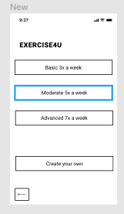

**Easy tracking and personal health data all on one page**

* You can track all of your health data and health progress all on one page, info such as weight progress will be displayed in graph form on the page for you better to visualize your progress
* The page is accessible from clicking on “Data” from the main page
* More metrics such as sleep tracking will be added in the future

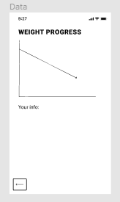

**Easy to use and access rewards page to further incentivize users to keep on track with their goals**

* You can redeem a variety of rewards as you accomplish the goals you set for yourself, these rewards will be anything from vouchers to gift cards to different vendors
* The page is accessible through “Rewards” from the main page
* Rewards are continually updated to keep them fresh

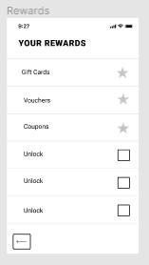

Below we have a basic overview of the application pages as a guide:

